SWAN Affiliate Budgeting Worksheet
User Guide



TABLE OF CONTENTS

Opening the SWAN ABW ...................................................................................................................3

Main Menu ..............................................................................................................................................4

Services Grid ...........................................................................................................................................6

Average Hours .......................................................................................................................................7
Screen Intro/Guidelines......................................................................................................................7
Navigation Menu ................................................................................................................................8
Adding Non-Post Perm Average Hours...............................................................................................9
Adding Post Perm Average Hours.......................................................................................................9

Worker Info ..........................................................................................................................................10
Screen Intro/Guidelines ....................................................................................................................10
Navigation Menu ..............................................................................................................................11
Cumulative Worker Costs and Hours ...............................................................................................12
Completing Worker Information ......................................................................................................13
Add A Worker Button .......................................................................................................................14
Remove A Worker Button ................................................................................................................15
Reset All Worker Info Button ...........................................................................................................16

Proposed Schedule ............................................................................................................................17
Screen Intro/Guidelines ....................................................................................................................17
Navigation Menu ..............................................................................................................................19
Services Table ...................................................................................................................................19
Viewing the Proposed Schedule .......................................................................................................20
Quarterly Workload ..........................................................................................................................23
Exclude Services Button ...................................................................................................................24
Include Services Button ....................................................................................................................25
Reset Services Button .......................................................................................................................26

Schedule ................................................................................................................................................27
Screen Intro/Guidelines ...................................................................................................................27
Navigation Menu ..............................................................................................................................28
Services Table ...................................................................................................................................28
View/Fill Out the Schedule ...............................................................................................................29
Add Service Button ...........................................................................................................................30
Remove Service Button ....................................................................................................................30
Available Hours & Worker Profit ......................................................................................................31
Quarterly Workload .........................................................................................................................32
Analyze Results Button .....................................................................................................................33
Reset Schedule Button .....................................................................................................................36

Go to Table of Contents

OPENING THE SWAN ABW

When you open the SWAN Affiliate Budgeting Worksheet, you may see the following two messages. Click “Enable Editing” and click “Enable Content”. You will then be taken to the Main Menu as designed.

Go to Table of Contents

MAIN MENU

When you open the SWAN Affiliate Budgeting Worksheet, you’ll be taken to the Main Menu.
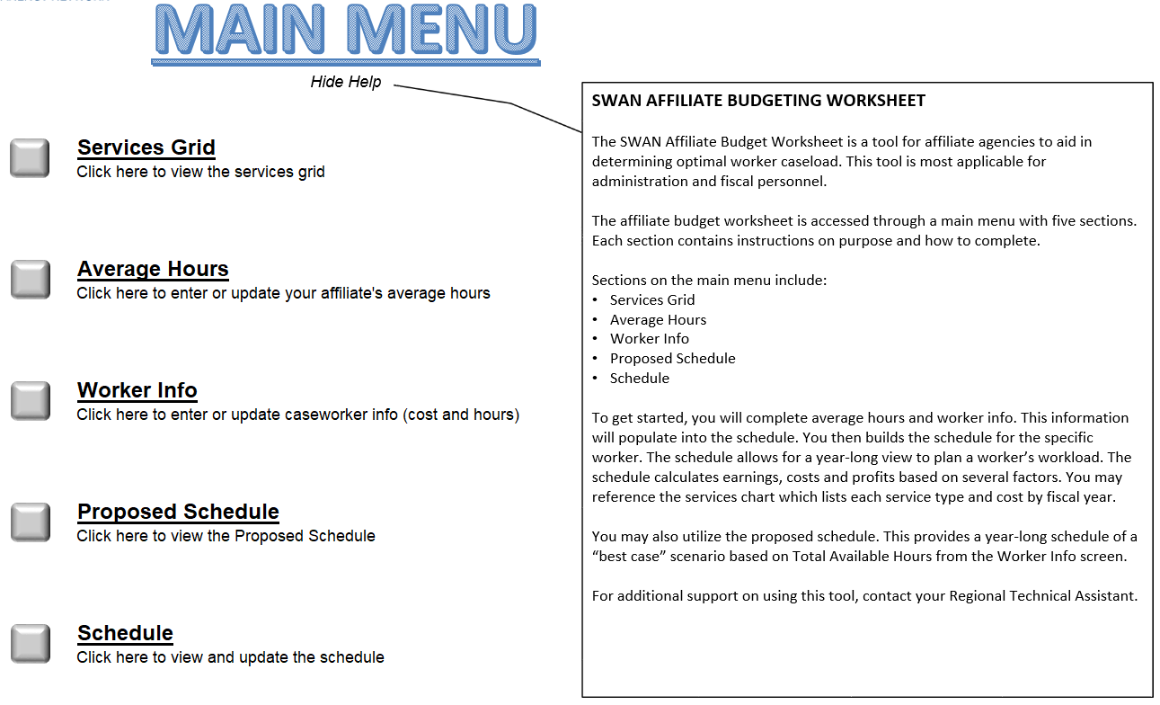
1
6
5
2
3
4
- On the right side of the screen, an explanation of the SWAN Affiliate Budgeting Worksheet displays by default. You can hide this window by clicking “Hide Help”. To open it again, click “Show Help”.

- Click this gray button to go to the Services Grid screen. This screen is where you can view each service’s rate and days to complete.

- Click on this gray button to go to the Average Hours screen. This screen is where you can enter/update each service’s average hours to complete.

- Click this gray button to go to the Worker Info screen. This is where you can enter/update worker information (salary and hours). The salary information will be used in the schedules to calculate costs. The hours will be used in the schedules to show if the worker’s maximum hours per month or hours per year is exceeded.

- Click this gray button to go to the Proposed Schedule screen. This is where you can view a best-case scenario schedule based on the information from the Average Hours screen and the Worker Info screen. You can only access this screen if the Average Hours screen and the Worker Info screen have been completed. If those screens are incomplete, you will not be able to click this gray button, and you’ll see a message in red explaining what needs to be completed before accessing the Proposed Schedule screen.

Go to Table of Contents
MAIN MENU
(continued)

- Click this gray button to go to the Schedule screen. This is where you can view and update your year-long schedule. You can only access this screen if the Average Hours screen and the Worker Info screen have been completed. If this information is not complete, you will not be able to click this gray button, and you’ll see a message in red explaining what needs to be completed before accessing the Schedule screen.

Go to Table of Contents

SERVICES GRID
The SERVICE GRID screen is where you can view the Rates and Days to Complete for each service. This information will be used in the schedules.

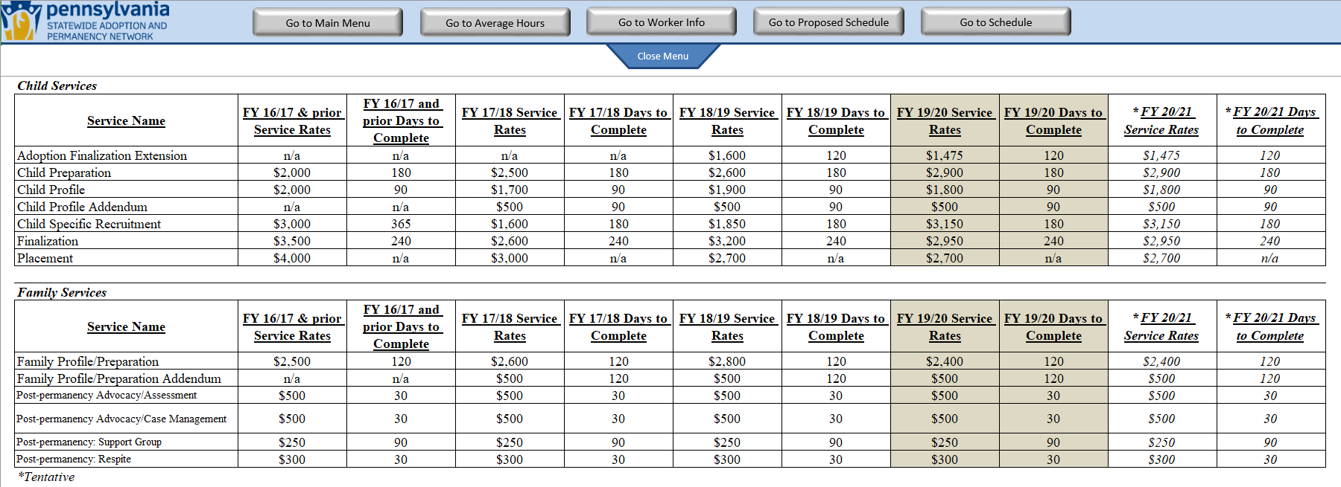
3
1
2
- At the top of the screen, you’ll see the Navigation Menu. By clicking the applicable button, you can navigate to any other screen. Please note that you can only click on the “Go to Proposed Schedule” button and the “Go to Schedule” button if the Average Hours screen and the Worker Info screen have been completed.

- To hide the Navigation Menu, click “Close Menu”. Click “Open Menu” to unhide the Navigation Menu.

- In the Services Grid, you can view the Rates and the Days to Complete of any service for any fiscal year. This information will be used in the schedules.

Go to Table of Contents

AVERAGE HOURS
The AVERAGE HOURS screen is where you will enter the average hours from your affiliate’s Cost-Time report.

SCREEN INTRO/GUIDELINES:
When you go to the Average Hours screen for the first time, you’ll see a window appear with a message. This message explains that there are some guidelines in this screen that you can click to help you understand some of the important details. If you don’t want this window to appear when you access this screen again during this session, check the “Don’t show this message in this screen again” box and click “OK”. Otherwise, just click the “OK” button. Also, you can click “Hide Help” to hide these guidelines. At that point, you can click “Show Help” to show them again.
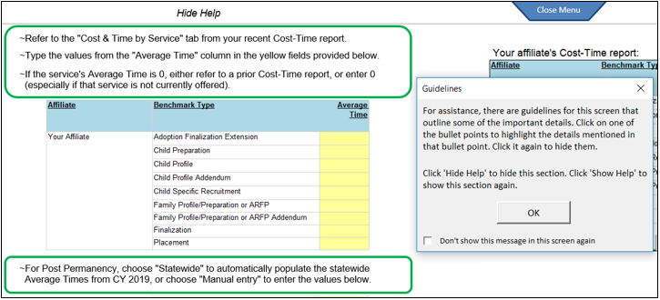
If you click on any of those bullet points, it’ll highlight what it’s referring to. In the example below, the bullet point referring to the Cost-Time report example was clicked, which then circles the example report. View any of the bullet points by clicking on them. Click it again to “un-highlight” the bullet point.
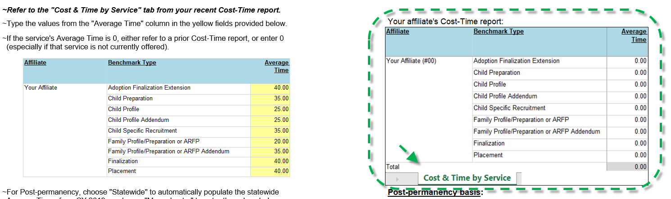
Go to Table of Contents
AVERAGE HOURS
(continued)

NAVIGATION MENU:
1
2

- At the top of the screen, you’ll see the Navigation Menu. By clicking the applicable button, you can navigate to another screen. Please note that you can only click on the “Go to Proposed Schedule” button and the “Go to Schedule” button if the Average Hours screen and the Worker Info screen have been completed.

- To hide the Navigation Menu, click “Close Menu”. Click “Open Menu” to unhide the Navigation Menu.

Go to Table of Contents
AVERAGE HOURS
(continued)

ADDING NON-POST PERM AVERAGE HOURS:
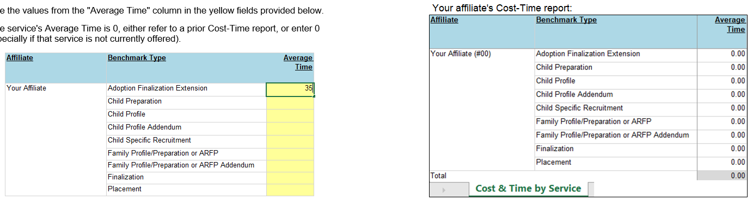
4
3

- Enter your affiliate’s total Average Hours from your most recent Cost-Time report.

- This example shows where to get the Average Hours/Times for each service from your recent Cost-Time report. You may need to reference a different Cost-Time report if one or more of the services is based on a low service count.

ADDING POST PERMANENCY AVERAGE HOURS:
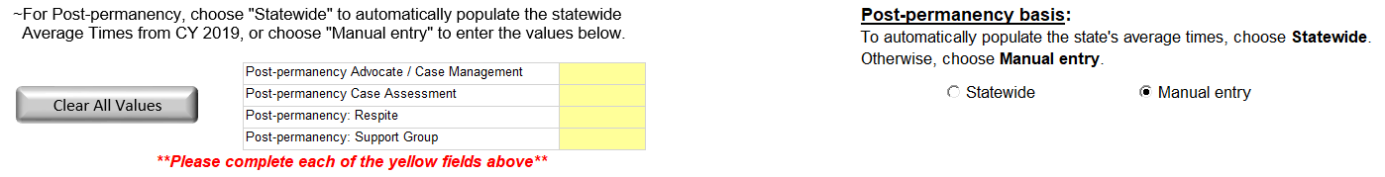
6
5

- Since Post-permanency services are not in the Cost-Time report, you can either select “Statewide” to have the Statewide average hours automatically populate, or select “Manual entry” to enter the average hours yourself.

- If entering manually, enter the Post-permanency average hours here. If populating the Statewide average hours, they will auto-populate here.
Go to Table of Contents

WORKER INFO
The WORKER INFO screen is where you’ll add as many workers as you want and include information related to their salary and their hours.

SCREEN INTRO/GUIDELINES:
When you go to the Worker Info screen for the first time, you’ll see a window appear with a message. This message explains that there are some guidelines in this screen that you can click to help you understand some of the important details. If you don’t want this window to appear when you access this screen again during this session, check the “Don’t show this message in this screen again” box and click “OK”. Otherwise, just click the “OK” button. Also, you can click “Hide Help” to hide these guidelines. At that point, you can click “Show Help” to show them again.
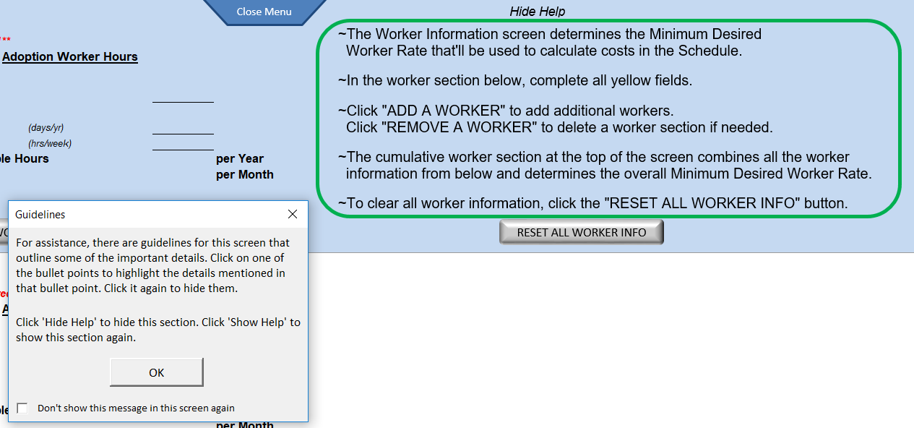

If you click on any of those bullet points, it’ll highlight what it’s referring to. In the example below, the bullet point referring to the “ADD A WORKER” button and the “REMOVE A WORKER” button was clicked, which then points to and circles those buttons. View any of the bullet points by clicking on them. Click it again to “un-highlight” the bullet point.
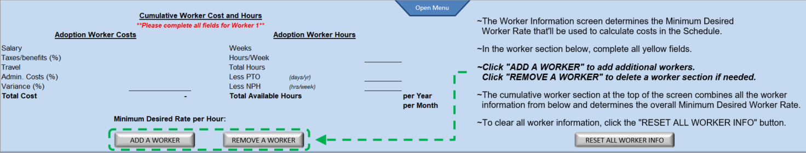
Go to Table of Contents
WORKER INFO
(continued)

NAVIGATION MENU:
1
2

- At the top of the screen, you’ll see the Navigation Menu. By clicking the applicable button, you can navigate to another screen. Please note that you can only click on the “Go to Proposed Schedule” button and the “Go to Schedule” button if the Average Hours screen and the Worker Info screen have been completed.

- To hide the Navigation Menu, click “Close Menu”. Click “Open Menu” to unhide the Navigation Menu.

Go to Table of Contents
WORKER INFO
(continued)

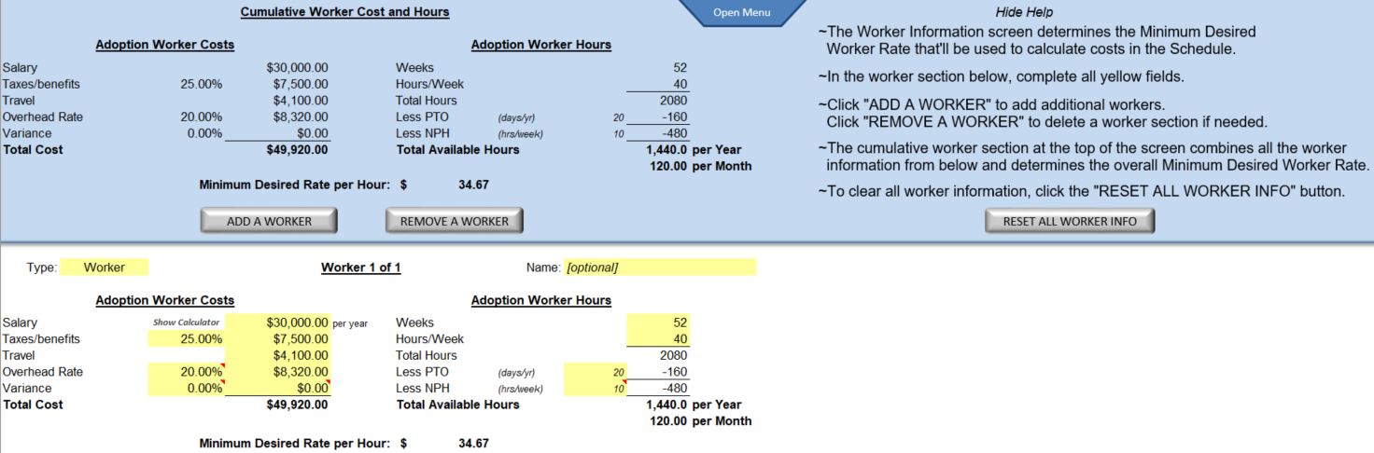
4
3
5
6
7

CUMULATIVE WORKER COST AND HOURS:
- Each field in the Cumulative Worker Cost and Hours section displays the totals from all of the workers that have been added (bottom section of the screen, white background area). However, if at least one of the required fields in any of the worker sections is not complete, the fields in the Cumulative Worker Cost and Hours section will be blank and a message will appear in red indicating which worker section is incomplete (e.g., “**Please complete all required fields for Worker 1**”).
- Total Cost: In the schedules, the Total Cost will be compared to the Total Earnings to determine the profit/loss.
- Total Available Hours per Year: This will be used in the schedules to show if the worker’s maximum hours per year is exceeded.
- Total Available Hours per Month: This will be used in the schedules to show if the worker’s maximum hours per month is exceeded.
- Minimum Desired Rate per Hour: This rate will be used to calculate worker costs in the schedules.

Go to Table of Contents
WORKER INFO
(continued)

COMPLETING WORKER INFORMATION:
- In the Worker sections (bottom of the screen, white background), complete each of the yellow fields as they are all required fields EXCEPT the Name field (this field is optional). A few fields (Overhead Rate, Variance, NPH) have additional comments to help explain what gets included in those fields. Hover your mouse over those fields to view the comments.
  - Type: Select the worker type. The appropriate fields will appear based on the selection.
  - Salary: Enter the worker’s annual salary. If you need help calculating the salary, click “Show Calculator”. In the Salary Calculator screen, enter the “Weeks per Year”, the “Hours per Week”, select the “Pay Rate Type”, and enter the “Pay Rate”. Then click “Calculate”. If the Calculated Salary looks satisfactory, click “Submit” and that salary, along with the entered “Weeks per Year” and “Hours per Week”, will populate in their respective fields in the Worker Info screen.
  - Taxes/benefits: Enter the worker’s taxes/benefits as a percentage or a dollar figure.
  - Travel: A default value appears, but you can change this if needed.
  - Overhead Rate: This field defaults to the current fiscal year’s statewide rate, but can be changed. Enter this as a percentage or a dollar figure.
  - Variance: If the worker's income may increase during the year for any reason (bonus, raise, overtime, etc.), you can account for the variance here. Enter this as a percentage or a dollar figure.
  - Name: This field defaults to “[optional]” because this is not a required field.
  - Weeks: This field defaults to “52”, but can be changed.
  - Hours/Week: Enter the worker’s hours per week.
  - PTO: Enter the worker’s PTO days per year.
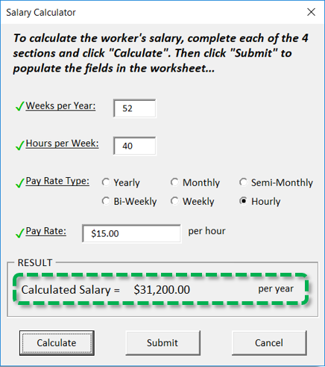
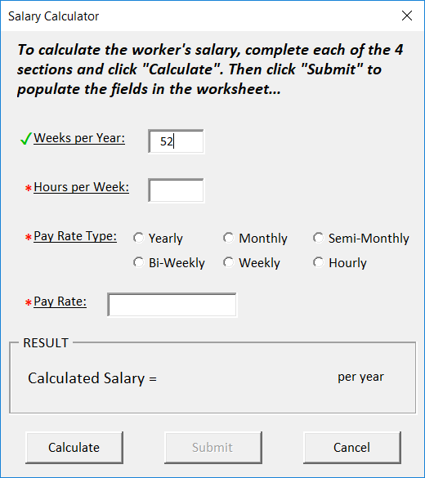
  - NPH: Enter the hours per week spent on non-SWAN work.

Go to Table of Contents
WORKER INFO
(continued)

ADD A WORKER BUTTON:
- Click the “ADD A WORKER” button if you want to add another worker. Complete the required yellow fields (Note: the Name field is not required.)
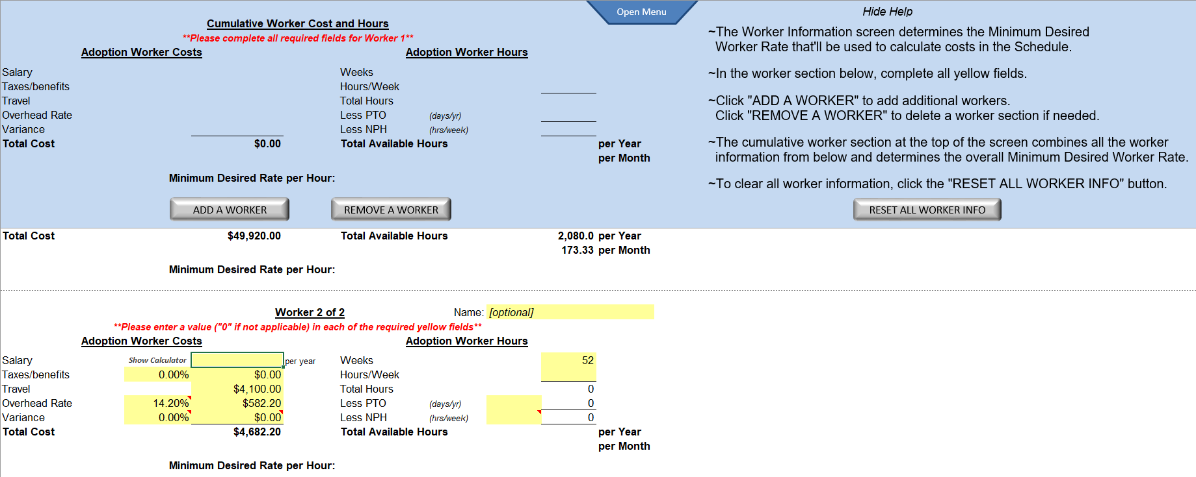

Go to Table of Contents
WORKER INFO
(continued)

REMOVE A WORKER BUTTON:
- Click the “REMOVE A WORKER” button if you want to delete a worker or multiple workers. A window will appear with a list of the workers that are currently in the Worker Info screen. Select the worker(s) from the list that you want to delete and click “Remove”.
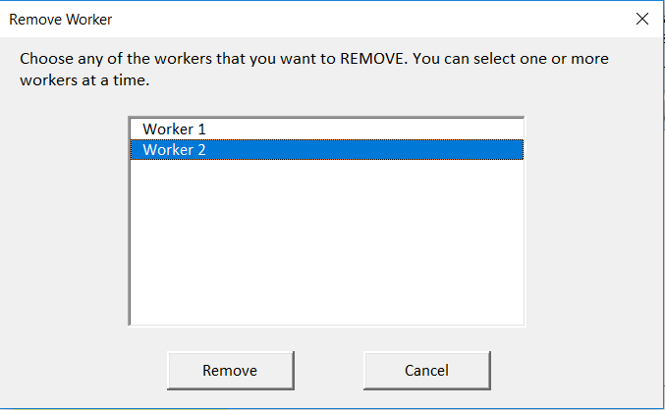
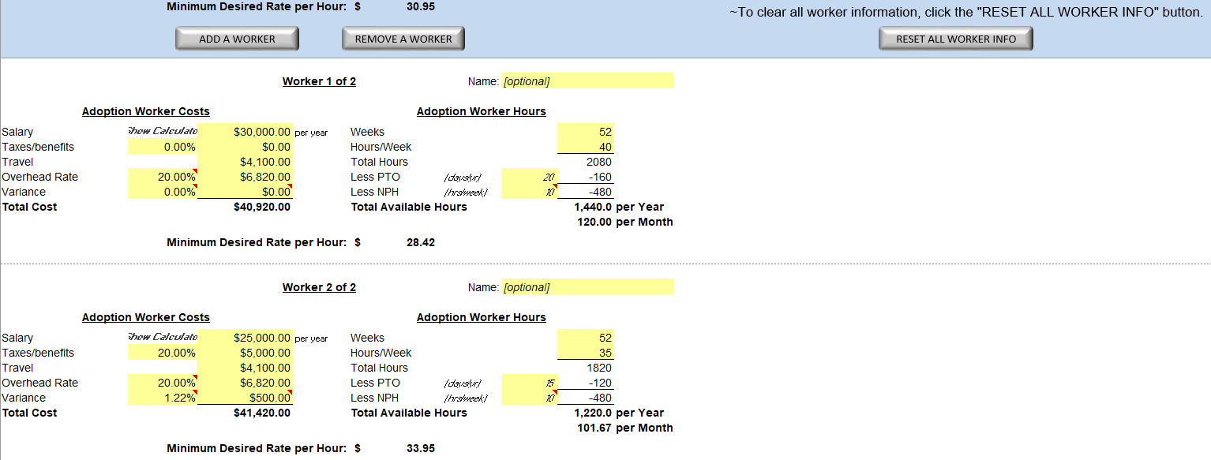

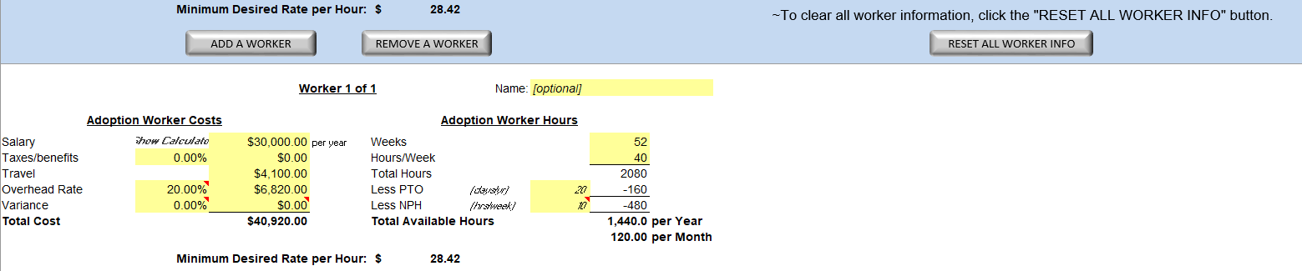

Go to Table of Contents
WORKER INFO
(continued)

RESET ALL WORKER INFO BUTTON:
- To clear all information in the Worker Info screen, click the “RESET ALL WORKER INFO” button. Click “Yes, please reset” to confirm that you want to clear the Worker Info screen.
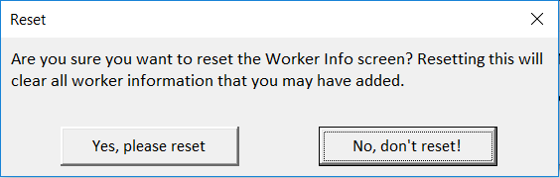
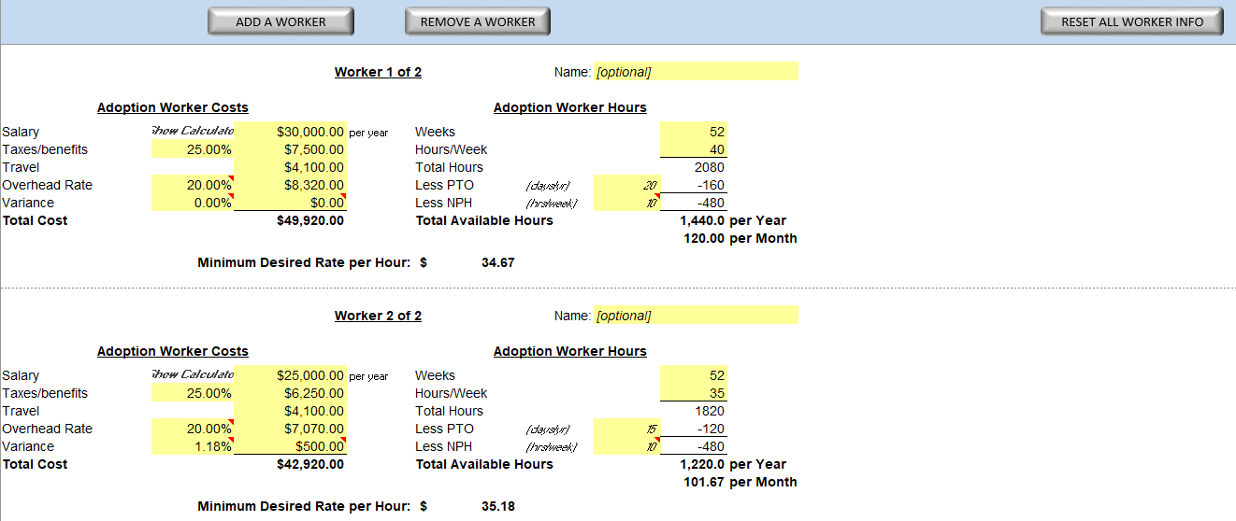
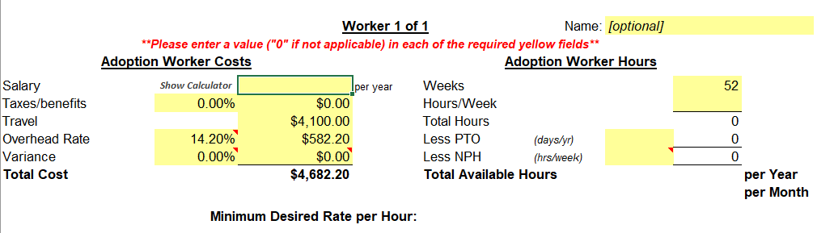
Go to Table of Contents

PROPOSED SCHEDULE
The PROPOSED SCHEDULE screen will automatically generate a best-case scenario schedule based on the information provided in the Worker Info screen.

SCREEN INTRO/GUIDELINES:
When you go to the Proposed Schedule screen for the first time, you’ll see a window appear with a message. This message explains that there are some guidelines in this screen that you can click to help you understand some of the important details. If you don’t want this window to appear when you access this screen again during this session, check the “Don’t show this message in this screen again” box and click “OK”. Otherwise, just click the “OK” button. Also, you can click “Hide Help” to hide these guidelines. At that point, you can click “Show Help” to show them again.
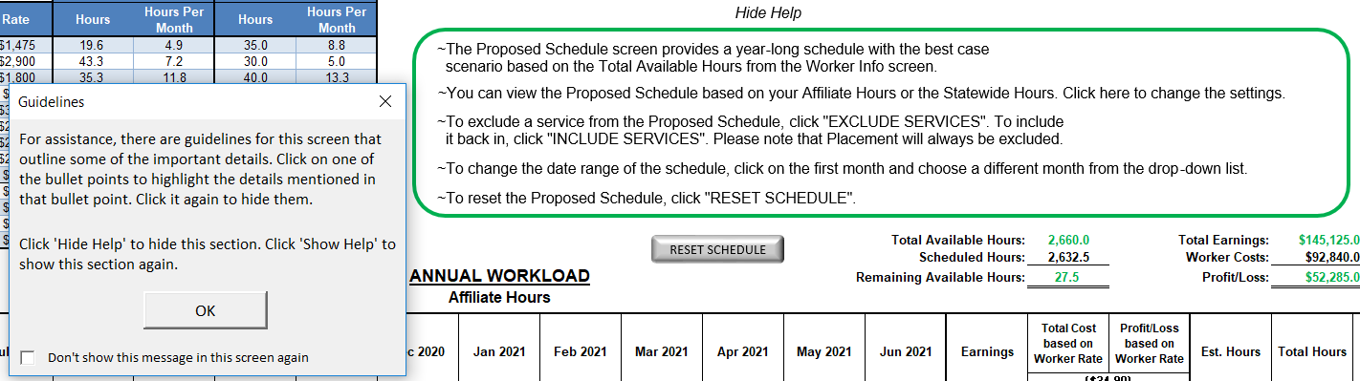

If you click on any of those bullet points, it’ll highlight what it’s referring to. In the example below, the bullet point referring to the “INCLUDE SERVICES” button and the “EXCLUDE SERVICES” button was clicked, which then points to and circles those buttons. View any of the bullet points by clicking on them. Click it again to “un-highlight” the bullet point.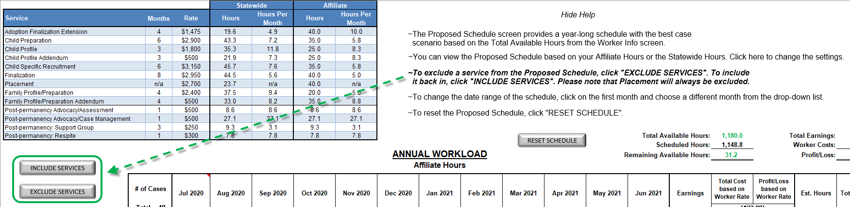
Go to Table of Contents
PROPOSED SCHEDULE
(continued)

After clicking “OK” in the window that explains the guidelines, another message will appear if at least one of the services is listed as zero hours in the Average Hours screen. The Proposed Schedule will automatically exclude that service, and this second message explains this while also highlighting the appropriate service(s) in the Services Table.
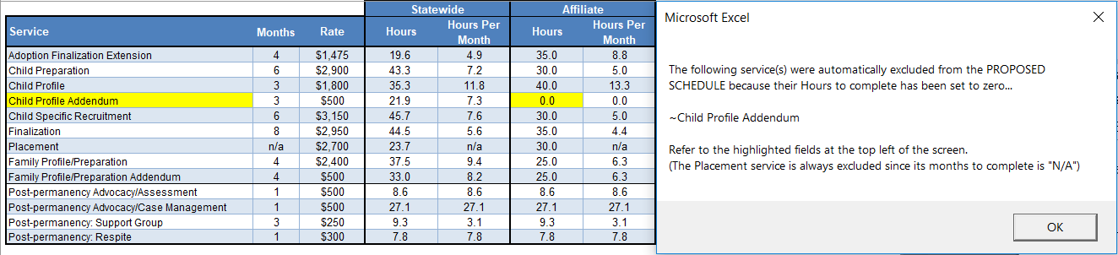

Go to Table of Contents
PROPOSED SCHEDULE
(continued)

NAVIGATION MENU:
1
2

- At the top of the screen, you’ll see the Navigation Menu. By clicking the applicable button, you can navigate to another screen.

- To hide the Navigation Menu, click “Close Menu”. Click “Open Menu” to unhide the Navigation Menu.

SERVICES TABLE:
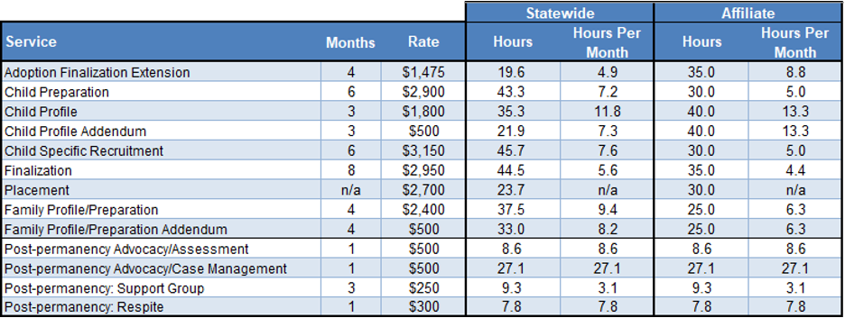
3

- The Services Table shows each service’s rate and months to complete, both come from the Services Grid screen. This table also shows each service’s Hours and Hours Per Month to complete, broken out between Statewide and Affiliate sections. The Hours from the Statewide section are automatically provided. The Hours from the Affiliate section come from the Average Hours section.
Go to Table of Contents
PROPOSED SCHEDULE
(continued)

VIEWING THE PROPOSED SCHEDULE:
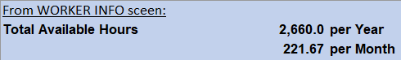
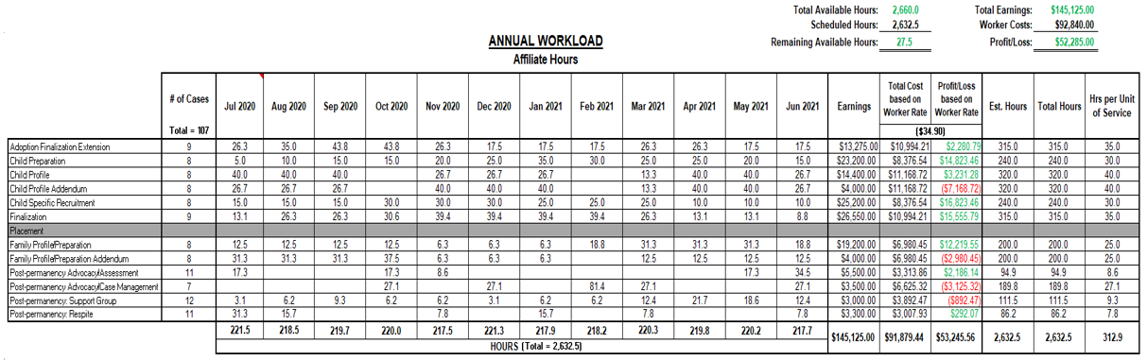
4
4b
4a

- The Proposed Schedule will automatically add the appropriate # of Cases and Hours Per Month for each service.
  - The total hours scheduled for the year will not exceed the Total Available Hours.
  - The total hours scheduled for each month will not exceed the Total Available Hours Per Month (from the Worker Info screen).
Go to Table of Contents
PROPOSED SCHEDULE
(continued)
11
5
9
8
10
7
6
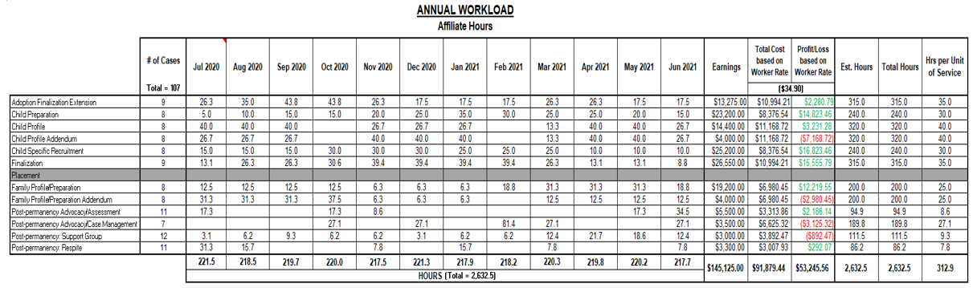
12

- The Earnings are calculated based on the service’s rate and the number of cases.
- The Total Cost based on Worker Rate is calculated based on the total hours scheduled times the Worker Rate.
- The Profit/Loss based on Worker Rate is the difference between the Earnings and the Total Cost based on Worker Rate.
- The Estimated Hours are calculated by multiplying the service’s hours (from the Services Table - #3) by the # of Cases. The service hours used in this calculation depend on what selection is made in #12.
- The Total Hours are the sum of the scheduled hours.
- The Hours per Unit of Service are the Total Hours divided by the # of Cases.
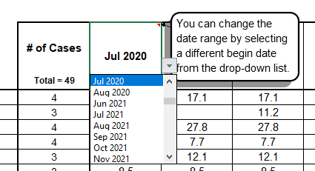
- To change the fiscal year of the schedule, click on the first month and select a new beginning month from the drop-down list. The other months will update accordingly.

Go to Table of Contents
PROPOSED SCHEDULE
(continued)

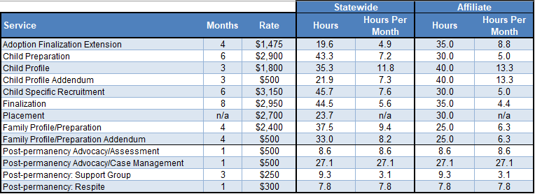

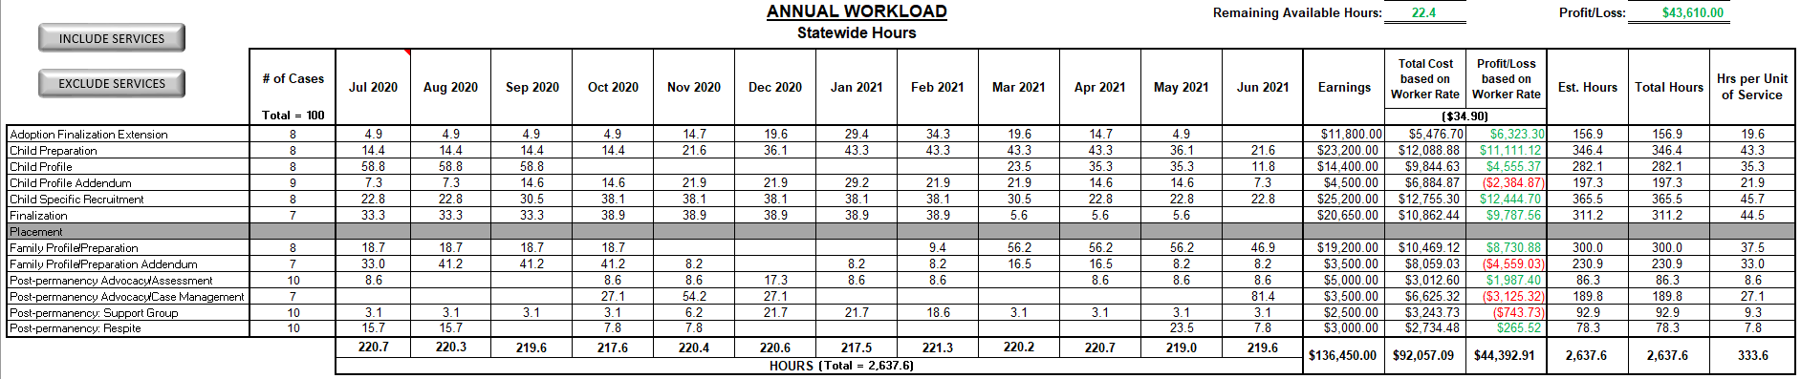

- Click on “Affiliate Hours” to change to “Statewide Hours”. Click on “Statewide Hours” to change to “Affiliate Hours”. Based on which is selected, the Proposed Schedule will recalculate using Hours and Hours Per Month from the Services Table.

Go to Table of Contents
PROPOSED SCHEDULE
(continued)
13

QUARTERLY WORKLOAD:
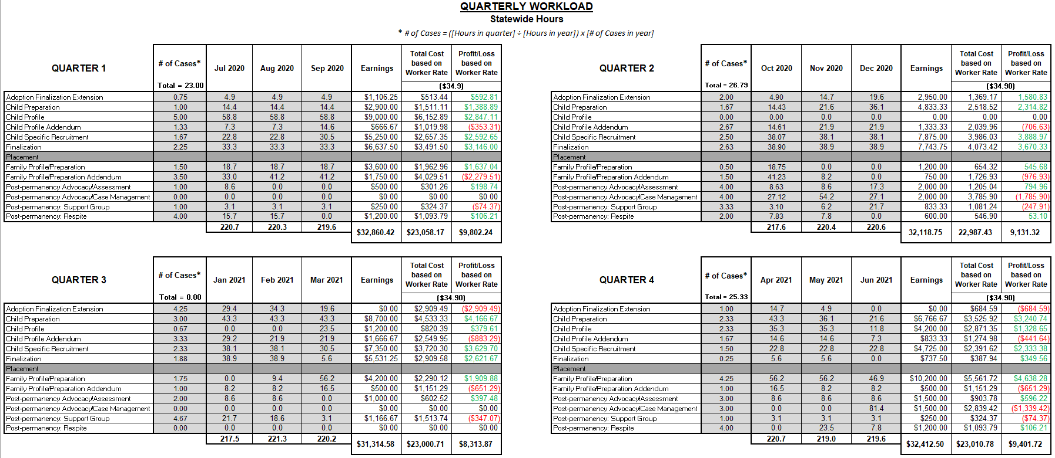

- At the bottom of the Proposed Schedule screen, there is a Quarterly Workload section that shows some of the same information as the Annual Workload section, but as a quarter-by-quarter breakdown. The Earnings, Total Cost, and Profit/Loss columns appear in the Quarterly Workload section as they do in the Annual Workload section.

Go to Table of Contents
PROPOSED SCHEDULE
(continued)

EXCLUDE SERVICES BUTTON:
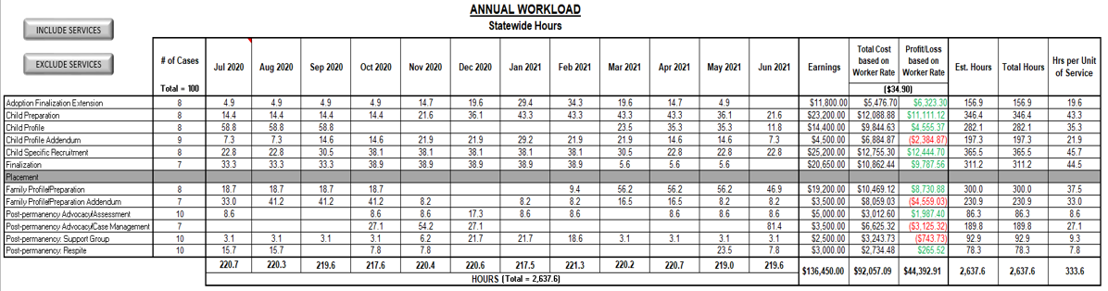
14

- To exclude certain services from being scheduled, click the Exclude Services button. Select the service(s) to exclude from the Exclude Service window (you can select more than one at a time) and click “Exclude”. The Proposed Schedule will then recalculate the best-case scenario schedule for all services except those that have been excluded.
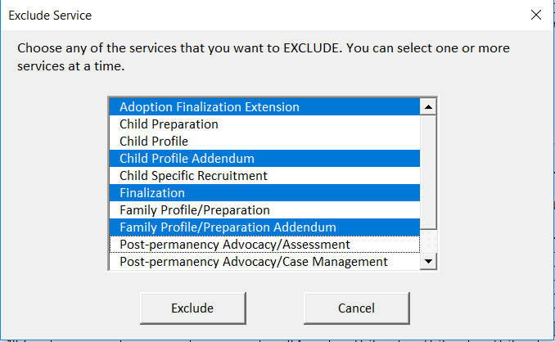

Go to Table of Contents
PROPOSED SCHEDULE
(continued)

INCLUDE SERVICES BUTTON:
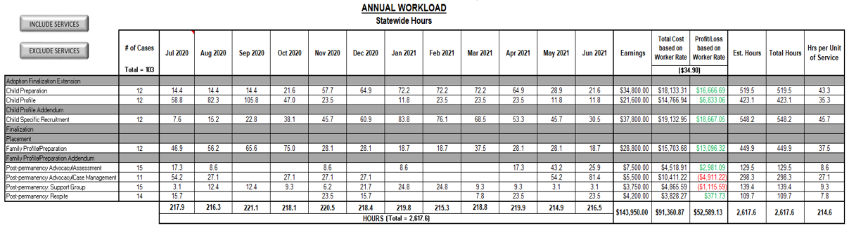
15

- To include a service that is currently excluded, click the Include Service button. Select the service(s) to include from the Include Service window (can select more than one at a time) and click “Include”. The Proposed Schedule will then recalculate the best-case scenario schedule with those services included.
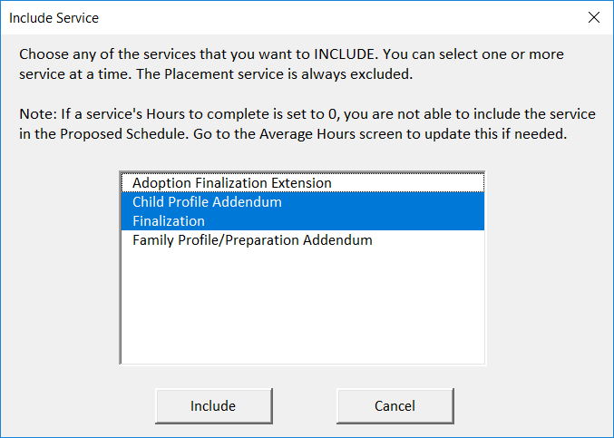

Go to Table of Contents
PROPOSED SCHEDULE
(continued)

RESET SCHEDULE BUTTON:
16

- If you simply want to reset the Proposed Schedule, click the “Reset Schedule” button. Click the “Yes, please reset” button when prompted, and the Proposed Schedule will recalculate the best-case scenario schedule with all services included.
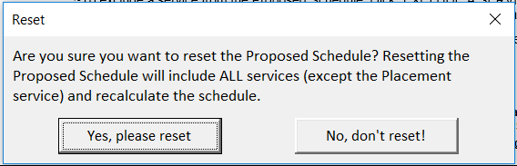

If at least one of the services is listed as zero hours in the Average Hours screen, it will automatically exclude that service when the Proposed Schedule resets. Also, a message will appear explaining this after clicking the “Reset Schedule” button, while highlighting the appropriate service(s) in the Services Table.
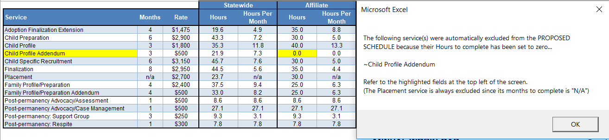

Go to Table of Contents

SCHEDULE
The SCHEDULE screen allows you to create a year-long schedule for your worker(s). Once you schedule the hours and # of cases, the Schedule will show whether or not the year is profitable.

SCREEN INTRO/GUIDELINES:
When you go to the Schedule screen for the first time, you’ll see a window appear with a message. This message explains that there are some guidelines in this screen that you can click to help you understand some of the important details. If you don’t want this window to appear when you access this screen again during this session, check the “Don’t show this message in this screen again” box and click “OK”. Otherwise, just click the “OK” button. Also, you can click “Hide Help” to hide these guidelines. At that point, you can click “Show Help” to show them again.
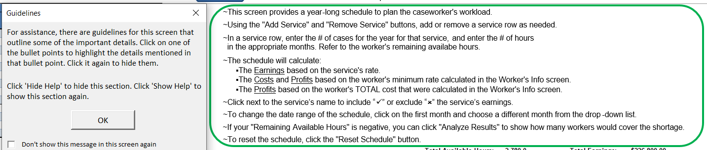

If you click on any of those bullet points, it’ll highlight what it’s referring to. In the example below, the bullet point referring to the “ADD SERVICE” button and the “REMOVE SERVICE” button was clicked, which then points to and circles those buttons. View any of the bullet points by clicking on them. Click it again to “un-highlight” the bullet point.
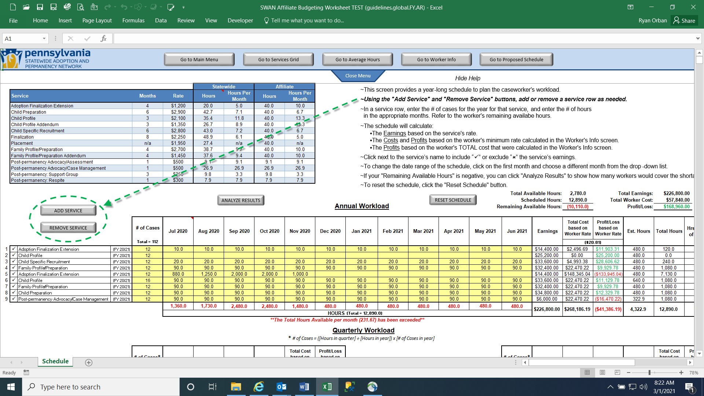

Go to Table of Contents
SCHEDULE
(continued)

NAVIGATION MENU:
1
2

- At the top of the screen, you’ll see the Navigation Menu. By clicking the applicable button, you can navigate to another screen.

- To hide the Navigation Menu, click “Close Menu”. Click “Open Menu” to unhide the Navigation Menu.

SERVICES TABLE:
3
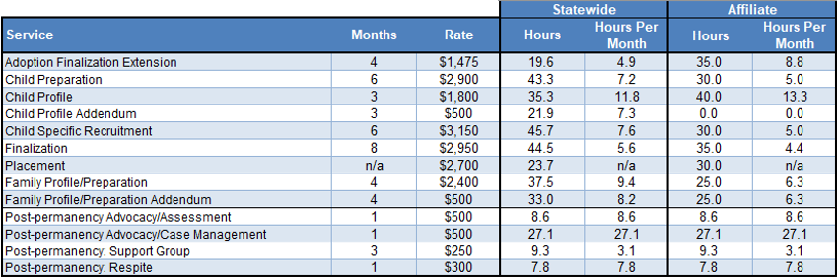

- The Services Table shows each service’s rate and months to complete, both come from the Services Grid screen. This table also shows each service’s Hours and Hours Per Month to complete, broken out between Statewide and Affiliate sections. The Hours from the Statewide section are automatically provided. The Hours from the Affiliate section come from the Average Hours section.

Go to Table of Contents
SCHEDULE
(continued)

VIEW/FILL OUT THE SCHEDULE:
5
11
10
9
7
8
6
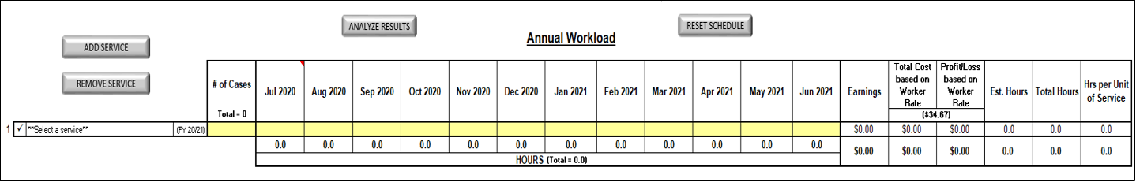
4b
4a
6a

- Choose a service and its fiscal year.
4a. Choose a service from the drop-down field.
4b. Choose a fiscal year from the drop-down field. The appropriate earnings will show based on the selected service and fiscal year.
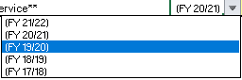
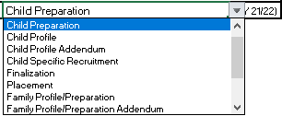

- Enter the # of Cases and the hours per month that you want to schedule. Once that is done, the following will show:
- Earnings - the service’s rate times the number of cases
6a. Click here to indicate if you want to include (“✓”) or exclude (“✗”) the service’s rate in the calculated Earnings.
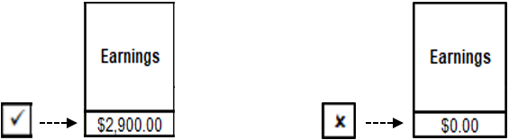
- Total Cost based on Worker Rate - the total hours scheduled times the Worker Rate
- Profit/Loss based on Worker Rate - the Earnings minus the Total Cost based on Worker Rate
- Estimated Hours - the service’s Affiliate Hours (from the Services Table - see #3) times the # of Cases
- Total Hours - the sum of the scheduled hours
- Hours per Unit of Service - the Total Hours divided by the # of Cases
Go to Table of Contents
SCHEDULE
(continued)

ADD SERVICE BUTTON:
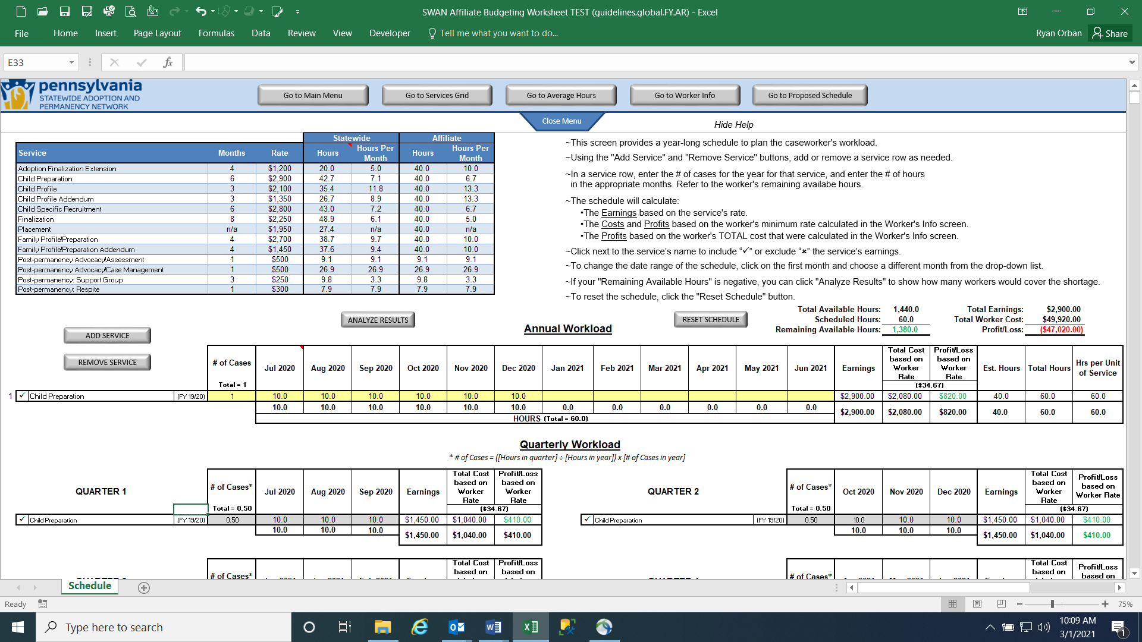
12..

- Click the ADD SERVICE button to add another service/row. Select the service from the drop-down field, select the fiscal year from the drop-down field, and enter the # of Cases and the hours per month that you want to schedule. Add as many services/rows as needed.

REMOVE SERVICE BUTTON:
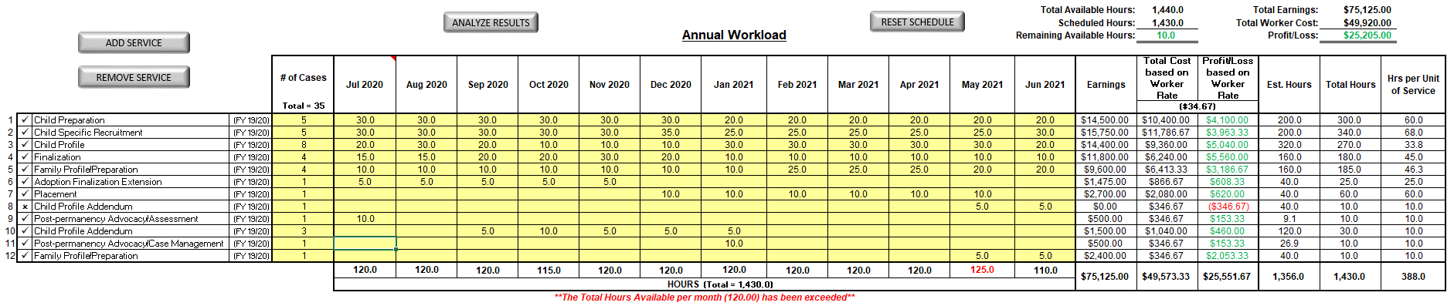
13

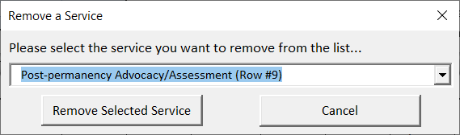
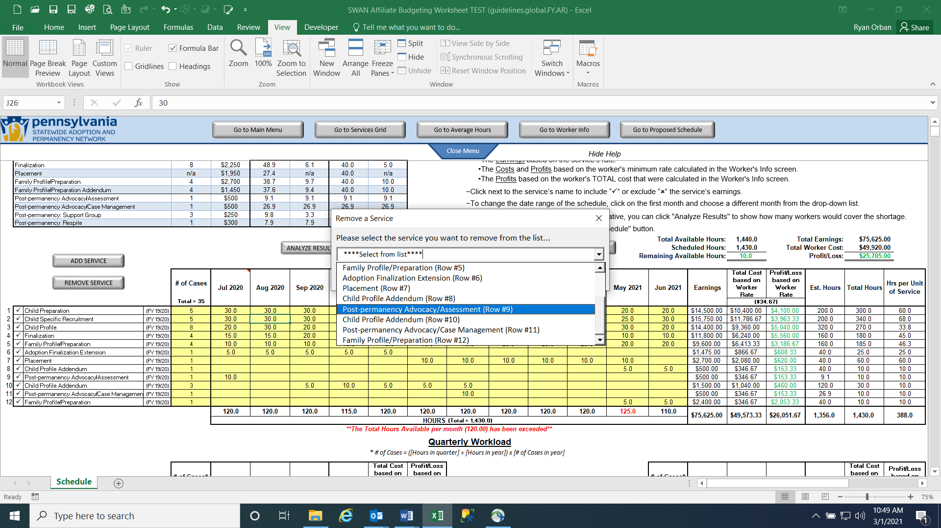
- Click the REMOVE SERVICE button to remove a service/row. Choose which service/row to remove from the schedule and click the “Remove Selected Service” button.

Go to Table of Contents
SCHEDULE
(continued)
15

AVAILABLE HOURS & WORKER PROFIT:
14
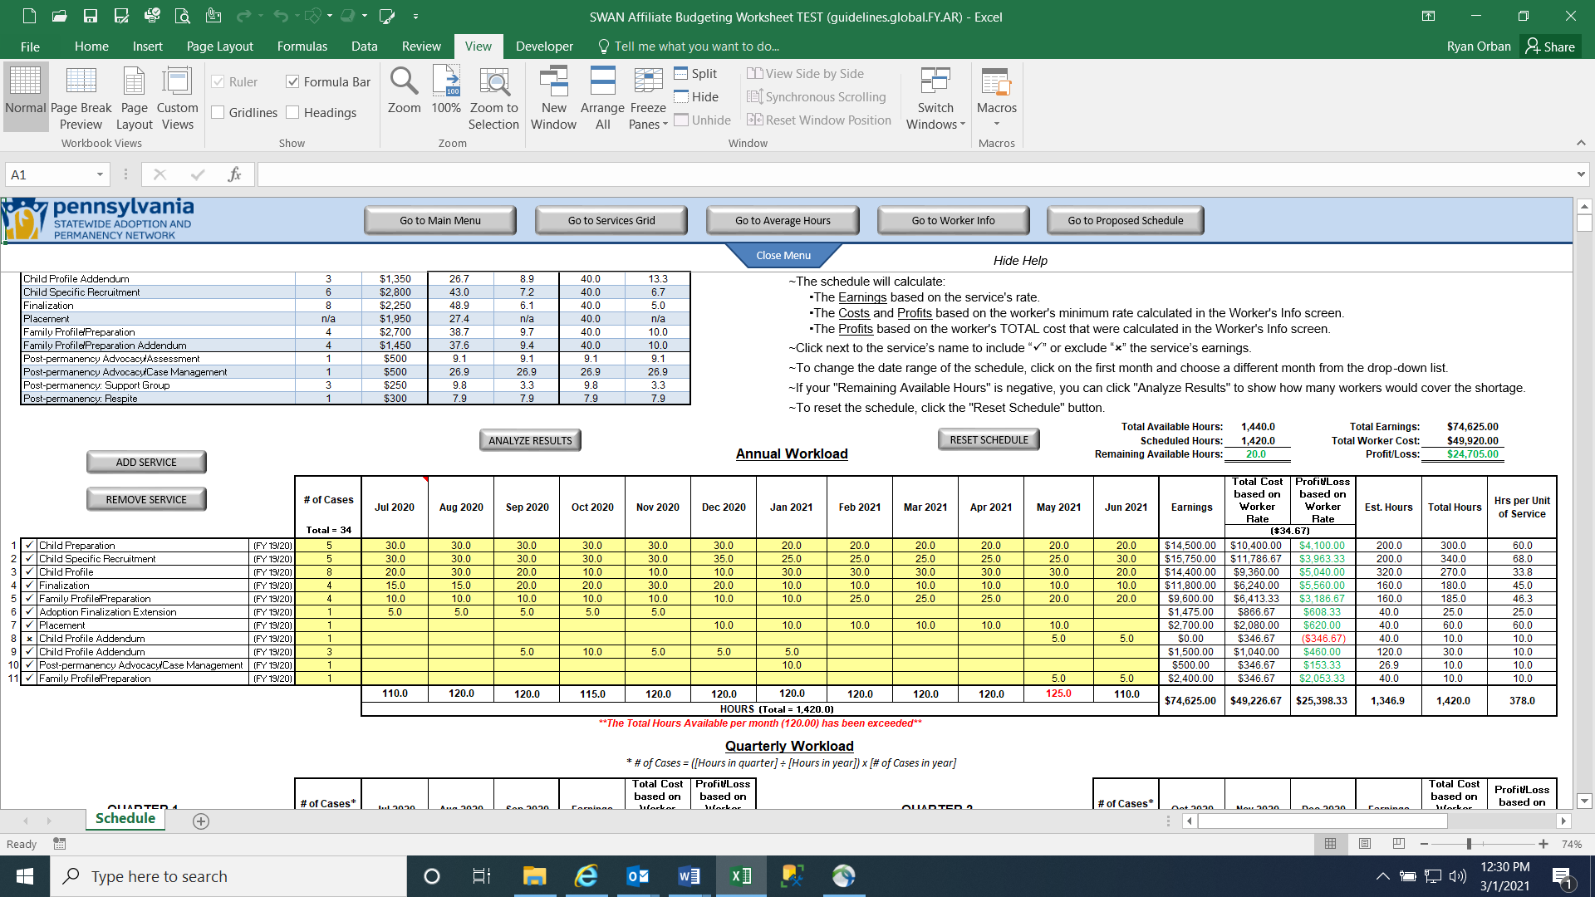
16

- As you fill out the schedule, the Remaining Available Hours will update. This shows the remaining hours from the worker’s Total Available Hours (from the Worker Info screen).
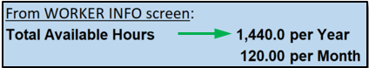
- The Total Earnings are compared to the Total Worker Cost (from the Worker Info screen) to determine if the schedule that you created is profitable.
- If the total hours scheduled per month exceeds the worker’s available hours per month (from the Worker Info screen), a warning message will appear.
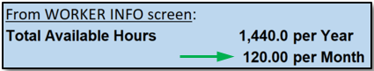
Go to Table of Contents
SCHEDULE
(continued)
17

QUARTERLY WORKLOAD:
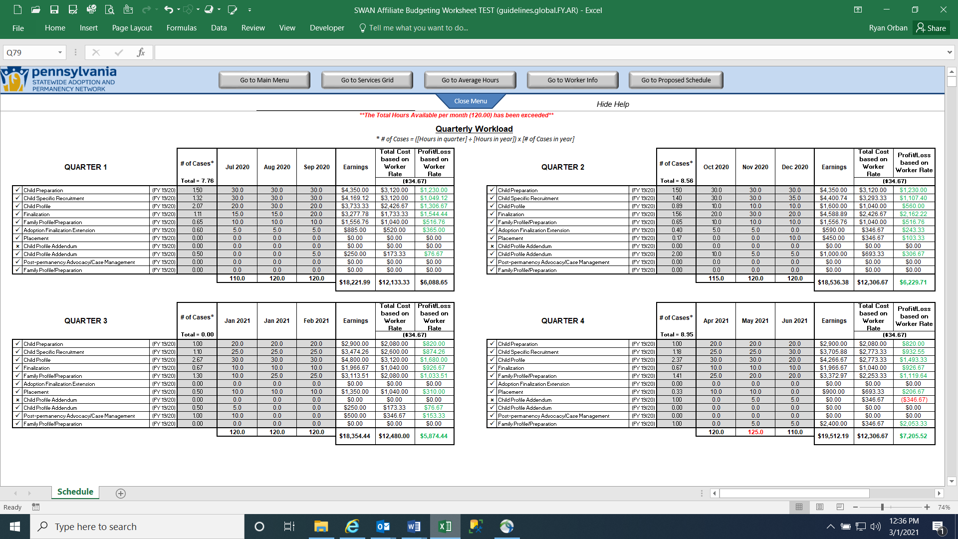

- At the bottom of the Schedule screen, there is a Quarterly Workload section that shows some of the same information as the Annual Workload section, but as a quarter-by-quarter breakdown. The Earnings, Total Cost, and Profit/Loss columns also appear in the Quarterly Workload section as it does in the Annual Workload section. The Quarterly Workload section is automatically completed based on the information you enter in the Annual Workload section.

Go to Table of Contents
SCHEDULE
(continued)

ANALYZE RESULTS BUTTON:
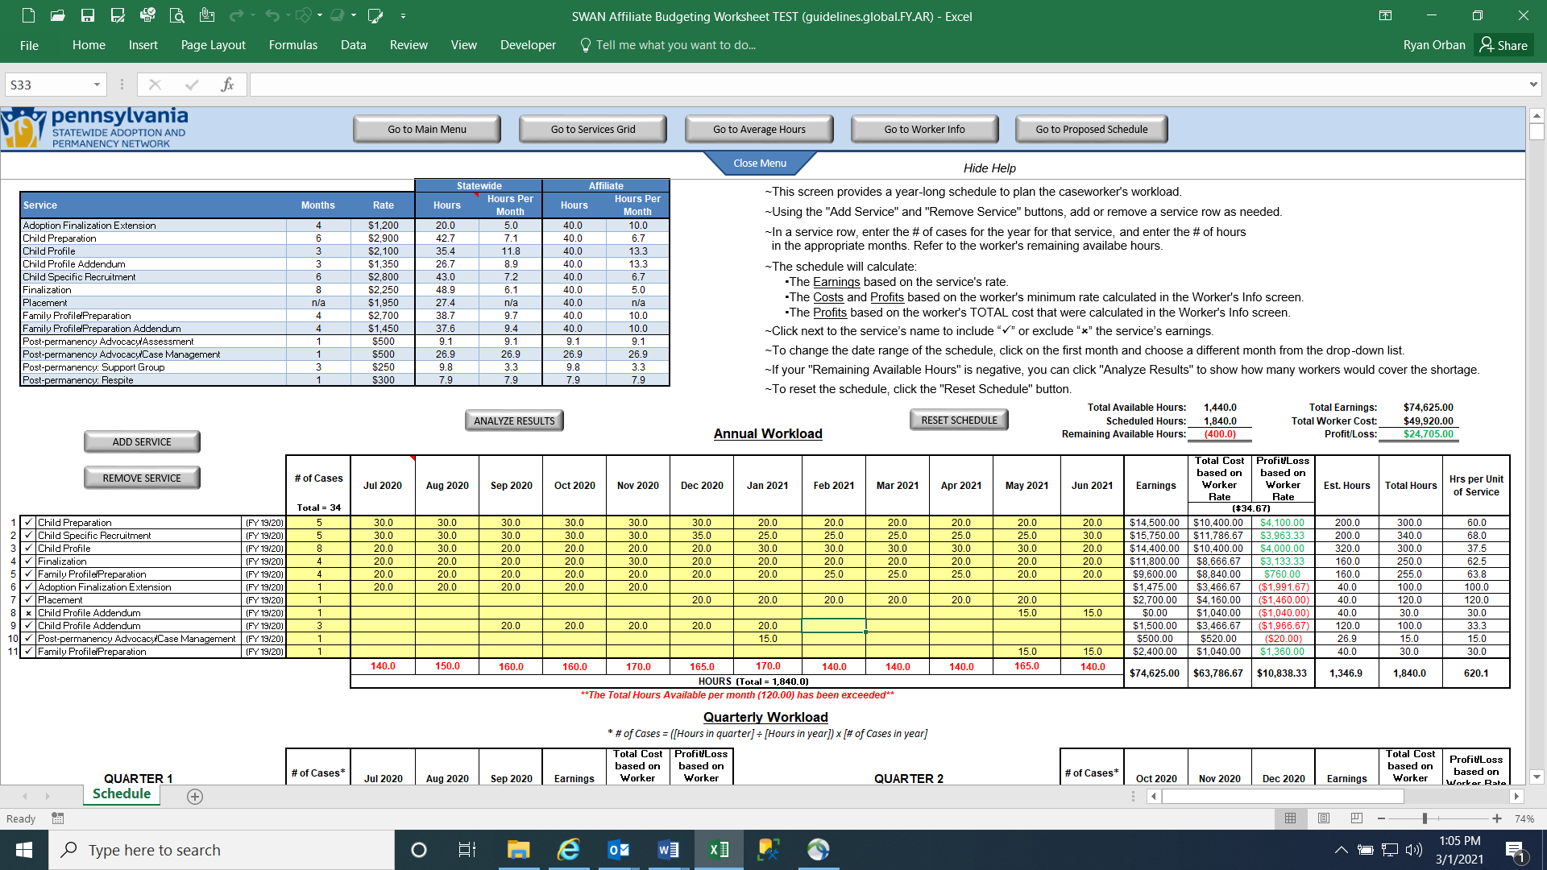
18
18

- Click the ANALYZE RESULTS button to have the Affiliate Budgeting Worksheet automatically determine how many workers will cover the Remaining Available Hours (if the Remaining Available Hours is negative). The Affiliate Budgeting Worksheet will use the workers entered in the Worker Info screen and determine how many of those workers (based on their Total Available Hours) will most efficiently cover Remaining Available Hours.

The results show that just one full-time worker (with 1,440 available hours) is the most efficient way to cover the 400 hours. If you click the ellipsis button (…), it will show the Worker Info setup that gets the Total Available Hours for that worker.
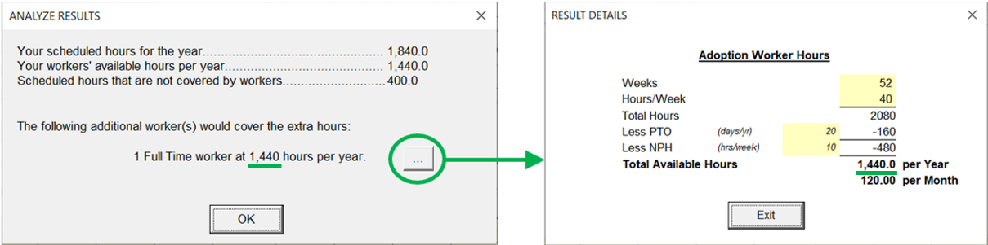
Go to Table of Contents
SCHEDULE
(continued)

However, if there are only full-time workers entered in the Worker Info screen, a window will first appear asking if you would also want to analyze a part-time worker (or if there are only part-time workers entered in the Worker Info screen, the window will ask if you would also want to analyze a full-time worker).
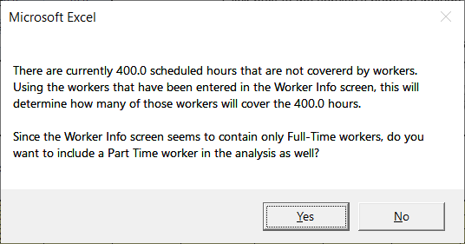

If you click “No”, it will simply show the results (as shown at the bottom of the previous page). If you click “Yes”, another window will appear for you to complete for the additional worker that will be analyzed. This window will look similar to the Worker Info section. Click “OK” when finished, or click “Cancel” to cancel out of this option.
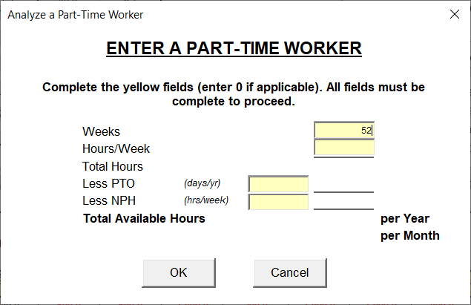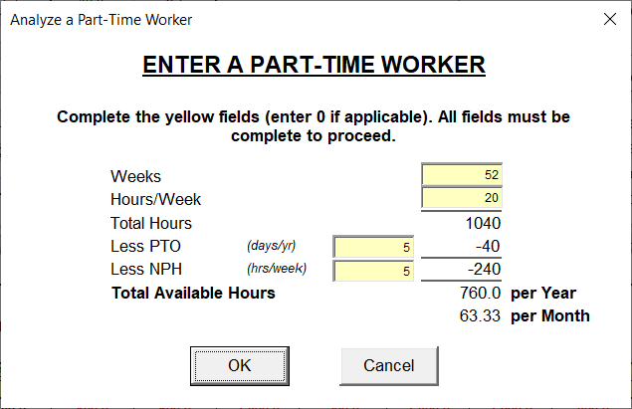

Go to Table of Contents
SCHEDULE
(continued)

The results will appear. In this example, the results show that one part-time worker (with 760 available hours) is the most efficient way to cover the 400 hours.
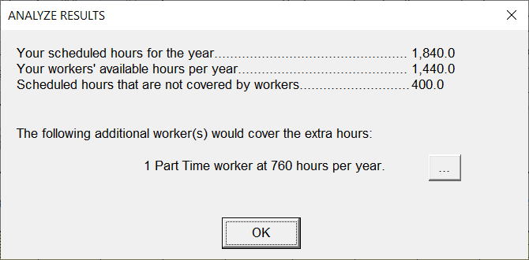

If there are only consultants entered in the Worker Info screen, a window will appear asking if you want to add a part-time worker, and full-time worker, or both for analysis purposes to determine how many workers would cover the 400 hours. You will be asked to enter the worker info and the results will display as shown above.
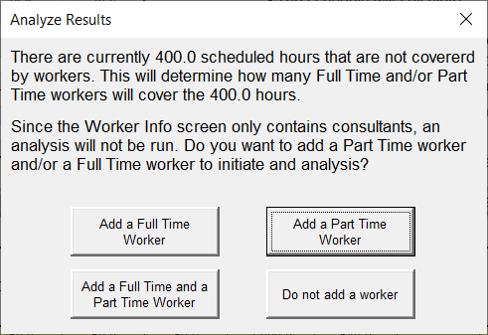

You can also choose to not add a part-time or full-time worker for this analysis. However, in that case, you will simply not have an analysis completed.
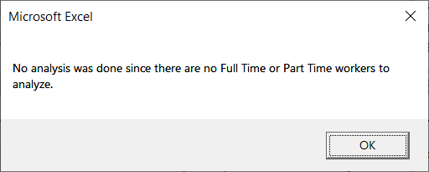
Go to Table of Contents
SCHEDULE
(continued)

RESET SCHEDULE BUTTON:
19

- If you simply want to reset the Schedule (remove all services/rows, hours, etc.), click the “RESET SCHEDULE” button. Click the “Yes, please reset” button when prompted, and the Schedule will reset back to one blank row.
